**Notice for 42nd batch**

**HOW TO ANSWER 2MBBS ANATOMY PAPER I & PAPER II**

**A lecture by Dr. E.I.Waidyarathne via zoom**

**On 30.08.2021**

**9-10.30 am**

[**https://learn.zoom.us/j/68064395322?pwd=Ykc5eVg1MVVTaEVDSVB0Y1JpMTRNZz09**](https://learn.zoom.us/j/68064395322?pwd=Ykc5eVg1MVVTaEVDSVB0Y1JpMTRNZz09)

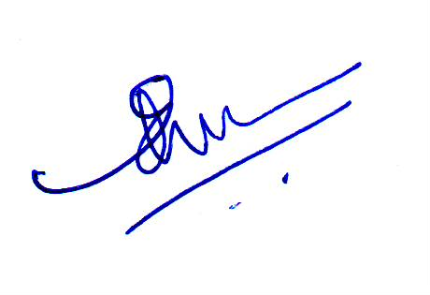

**Dr. E.I Waidyarathne**

**Head/ Anatomy**